SOFTWARE REQUIREMENTS SPECIFICATION

**For**

**Blog Platform**

Done by :

Kavirajan P

Nirmal

Lingeshwaran K V

# Introduction

## Purpose

The main objective of this document is to illustrate the requirements for the development of Blog Platform project. The document gives the detailed description of the both functional and non-functional requirements proposed by the client. The purpose of this project is to provide a user-friendly platform tailored for managing blog content effectively. The main purpose of this project is to maintain easy circulation system using computers and to provide different reports. This project describes the hardware and software interface requirements using ER diagrams and UML diagrams.

## Document Conventions

* + - Entire document should be justified.
    - Convention for Main title

Font face: Times New Roman Font style: Bold

Font Size: 14

* + - Convention for Sub title

Font face: Times New Roman Font style: Bold

Font Size: 12

* + - Convention for body

Font face: Times New Roman Font Size: 12

## Scope of Development Project

Blog Platform is an online platform where users can create new blogs, update previous blogs, delete blogs and view other user’s blog according to their interest and category. Users can also comment and like to other blogs.

The project is specifically designed for the content creators and to exchange ideas. The platform can be a useful tool for marketing and branding. This platform can be used by any people those who are interested to scocialise.

The project can be easily implemented under various situations. We can add new features as and when we require, making usability possible as there is flexibility in all the modules. The language used for developing the project is Java as it is quite advantageous than other languages in terms of performance, tools available, cross platform compatibility, libraries, cost (freely available), and development process.

## Definitions, Acronyms and Abbreviations

JAVA -> platform independence SQL-> Structured query Language ER-> Entity Relationship

UML -> Unified Modeling Language

IDE-> Integrated Development Environment SRS-> Software Requirement Specification

# Overall Descriptions

## Product Perspective

Use Case Diagram of Blog Platform

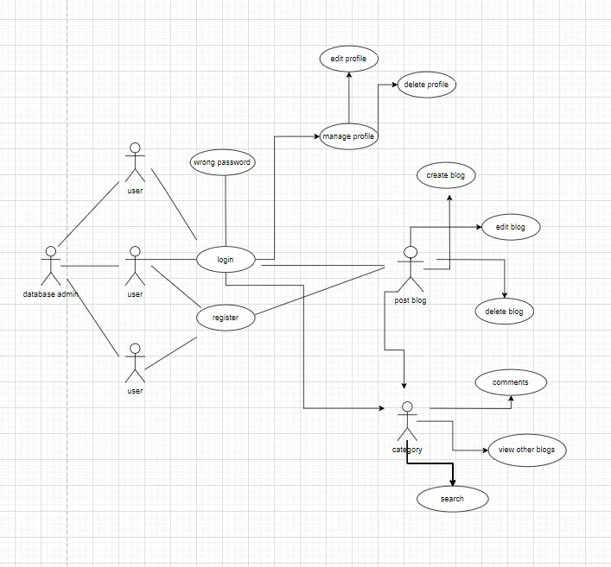

This is a broad level diagram of the project showing a basic overview. The users can be either viewer or blog creator. This System will provide a search functionality to facilitate the search of resources. This search will be based on various categories viz. blog type or according to their interest .

## Product Function

Entity Relationship Diagram of Blog System

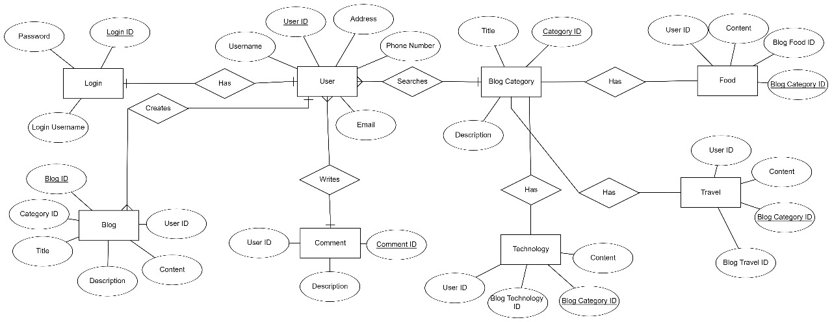

The Online Blog Platform is designed to offer real-time information about available blog posts and user profiles within the platform. The primary objective of this project is to streamline processes and minimize manual efforts. This software efficiently handles diverse functionalities such as creating and managing blogs, tracking issues and returns and generating customized reports for record-keeping based on user preferences. Serving as the platform administrator, the Blog Manager oversees member accounts and blog content. The system maintains up-to-date records of member interactions with blogs, and user details can be easily accessed by the administrator when needed. Additionally, registered users have the privilege to view and manage their account information.

## User Classes and Characteristics

The platform provides different types of services based on the type of Admins [Create, Edit,View and Delete Blog]. The Admin will be acting as the controller of the blog and he will have all the privileges of an administrator. The Admin of the blog who will be accessing the Blogs online.

The features that are available to the Users are:-

* + - An User can create, view, delete or edit the blog created by him/her.
    - Users can view the blogs with respect to different categories
    - Users can view the number of accounts who have viewed their blog.
    - Users can view the comments but cannot edit the comments.
    - User can view all the blogs.
    - User can comment or review the blog created by an another user.
    - Users can add, view, delete comments.

## Operating Environment

The product will be operating in windows environment. The Blog platform is a website and shall operate in all famous browsers, for a model we are taking Microsoft Internet Explorer, Google Chrome, and Mozilla Firefox. Also it will be compatible with the IE 6.0. Most of the features will be compatible with the Mozilla Firefox & Opera 7.0 or higher version. The only requirement to use this online product would be the internet connection.

The hardware configuration include Hard Disk: 40 GB, Monitor: 15” Color monitor, Keyboard: 122 keys. The basic input devices required are keyboard, mouse and output devices are monitor, printer etc.

## Assumptions and Dependencies

The assumptions are:-

* + - The coding should be error free
    - The system should be user-friendly so that it is easy to use for the users
    - The information of all users, blogs and other details must be stored in a database that is accessible by the website
    - The system should have more storage capacity and provide fast access to the database
    - The system should provide search facility and support quick transactions
    - The blog platform is running 24 hours a day
    - Users must have their correct usernames and passwords to enter into their online accounts and do actions

The dependencies are:-

* + - The specific hardware and software due to which the product will be run
    - On the basis of listing requirements and specification the project will be developed and run
    - The end users (admin) should have proper understanding of the product
    - The system should have the general report stored
    - The information of all the users must be stored in a database that is accessible by the system administrator
    - Any update regarding the blog to be recorded to the database and the data entered should be correct

## Requirement

Software Configuration:-

This software package is developed using java as front end which is supported by sun micro system. Microsoft SQL Server as the back end to store the database.

Operating System: Windows NT, windows 98, Windows XP Language: Java Runtime Environment, Net beans 7.0.1 (front end) Database: MS SQL Server (back end)

Hardware Configuration:- Processor: Pentium(R)Dual-core CPU Hard Disk: 40GB

RAM: 256 MB or more

## Data Requirement

The inputs consist of the query to the database and the output consists of the solutions for the query. The output also includes the user receiving the details of their accounts. In this project the inputs will be the queries as fired by the users like create an account, create blogs and putting into account. Now the output will be visible when the user requests the server to get details of their account , what blog has been posted, how many blogs has been posted etc.

# External Interface Requirement

## GUI

The Platform provides good graphical interface for the users and can operate on the system, performing the required task such as create, update, view or delete the blogs.

* + - It allows user to view the blogs him/her have posted.
    - It provides search facility based on different categories of blogs.
    - All the modules provided with the software must fit into this graphical user interface and accomplish to the standard defined
    - The design should be simple and all the different interfaces should follow a standard

template

* + - The user interface should be able to interact with the user management module and a part of the interface must be dedicated to the login/logout module

Login Interface:-

In case the user is not yet registered, he can enter the details and register to create his account. Once his account is created he can ‘Login’ which asks the user to type his username and password. If the user entered either his username or password incorrectly then an error message appears.

Search:-

The User can enter the type of blog he/she is looking for and the title he/she is interested in,then he/she can search for the required blog by entering the blog name.

Categories View:-

Categories view shows the categories of blogs available and provides ability to the User to add new category from the list of blogs.

User’s Control Panel:-

This control panel will allow Users to add blogs and manage viewing options for the blog.

# System Features

The users of the system should be provided the surety that their account is secure. This is possible by providing:-

* User authentication and validation of members using their unique UID
* Proper accountability which includes not allowing a member to see other member’s account. Only the user can see and manage his account.

# Other Non-functional Requirements

## Performance Requirement

The proposed system that we are going to develop will be used as the Chief performance system within the different campuses of the university which interacts with the university staff and students. Therefore, it is expected that the database would perform functionally all the requirements that are specified by the university.

* + - The performance of the system should be fast and accurate
    - Blog platform shall handle expected and non-expected errors in ways that prevent loss in information and long downtime period. Thus it should have inbuilt error testing to identify invalid username/password
    - The system should be able to handle large amount of data. Thus it should accommodate high number of books and users without any fault

## Safety Requirement

The database may get crashed at any certain time due to virus or operating system failure. Therefore, it is required to take the database backup so that the database is not lost. Proper UPS/inverter facility should be there in case of power supply failure.

## Security Requirement

* + - System will use secured database
    - Normal users can just read information but they cannot edit or modify anything except their personal and some other information.
    - System will have different types of users and every user has access constraints
    - Proper user authentication should be provided
    - No one should be able to hack users’ password
    - There should be separate accounts for admin and members such that no member can access the database and only admin has the rights to update the database.

## Requirement attributes

* + - There may be multiple admins creating the project, all of them will have the right to create changes to the system. But the members or other users cannot do changes
    - The project should be open source
    - The Quality of the database is maintained in such a way so that it can be very user friendly to all the users of the database
    - The user be able to easily download and install the system

## Business Rules

A business rule is anything that captures and implements business policies and practices. A rule can enforce business policy, make a decision, or infer new data from existing data.This includes the rules and regulations that the System users should abide by. This includes the cost of the project and the discount offers provided. The users should avoid illegal rules and protocols. Neither admin nor member should cross the rules and regulations.

## User Requirement

The users of the system are people and a person administrator to maintain the system. The members are assumed to have basic knowledge of the computers and internet browsing. The administrators of the system should have more knowledge of the internals of the system and is able to rectify the small problems that may arise due to disk crashes, power failures and other catastrophes to maintain the system. The proper user interface, user manual, online help and the guide to install and maintain the system must be sufficient to educate the users on how to use the system without any problems.

The admin provides certain facilities to the users in the form of:-

* + - Backup and Recovery
    - Forgot Password
    - Data migration i.e. whenever user registers for the first time then the data is stored in the server
    - Data replication i.e. if the data is lost in one branch, it is still stored with the server
    - Auto Recovery i.e. frequently auto saving the information
    - Maintaining files i.e. File Organization
    - The server must be maintained regularly and it has to be updated from time to time

# Other Requirements

## Data and Category Requirement

There are different categories of users namely blog creator, blog viewers, Admin, etc. Depending upon the category of user the access rights are decided.It means if the user is an administrator then he can be able to modify the data,delete, append etc. If the user is a blog creator, he can create, edit or delete his blog but no the others. If the user is a blog viewer, he can add comments to other blogs but can’t delete or edit other’s blogs. Similarly there will be different categories of blogs available. According to the categories of blogs their relevant data should be displayed. The categories and the data related to each category should be coded in the particular format.

## Appendix

A: Admin, Abbreviation, Acronym, Assumptions; B: Blog, Business rules; C: Class, Client, Conventions; D: Data requirement, Dependencies; G: GUI; K: Key; M: Member; N: Non-functional Requirement; O: Operating environment; P: Performance,Perspective,Purpose; R: Requirement, Requirement attributes; S: Safety, Scope, Security, System features; U: User, User class and characteristics, User requirement;

## Glossary

The following are the list of conventions and acronyms used in this document and the project as well:

* + - Administrator: A login id representing a user with user administration privileges to the software
    - User: A general login id assigned to most users
    - Client: Intended users for the software
    - SQL: Structured Query Language; used to retrieve information from a database
    - SQL Server: A server used to store data in an organized format
    - Layer: Represents a section of the project
    - User Interface Layer: The section of the assignment referring to what the user interacts with directly
    - Application Logic Layer: The section of the assignment referring to the Web Server. This is where all computations are completed
    - Data Storage Layer: The section of the assignment referring to where all data is recorded
    - Use Case: A broad level diagram of the project showing a basic overview
    - Class diagram: It is a type of static structure diagram that describes the structure of a system by showing the system’s cases, their attributes, and the relationships between the classes
    - Interface: Something used to communicate across different mediums
    - Unique Key: Used to differentiate entries in a database

## Class Diagram

A class is an abstract, user-defined description of a type of data. It identifies the attributes of the data and the operations that can be performed on instances (i.e. objects) of the data. A class of data has a name, a set of attributes that describes its characteristics, and a set of operations that can be performed on the objects of that class. The classes’ structure and their relationships to each other frozen in time represent the static model. In this project there are certain main classes  
which are related to other classes required for their working. There are different kinds of relationships between the classes as shown in the diagram like normal association, aggregation, and generalization. The relationships are depicted using a role name and multiplicities. Here ‘User’, ‘Blog’ and ‘Blog category’ are the most important classes which are related to other classes.

